UNEARTHING THE ENVIRONMENT IMPACT OF HUMAN ACTIVITY : A GLOBAL CO2 EMISSION ANALSIS

1. **INTRODUCTION**

**1.1 OVERVIEW :**

**Co2 Emission are the those stemming from the burning of fossil fuels and the manufacture of cement. They include co2 produced during consumption of solid, liquid, and gas fuels and gas flaring.Co2 Emission largely by -products of energy production and use, account for the largest share of greenhouse gases, which are associated with global warming.**

**1.2 PURPOSE :**

Co2 is Earth’s most important greenhouse gas : a gas that absorbs and radiates heat. Unlike oxygen and nitrogen , Greenhouse gases absorbs heat radiating from the earth’s surface and re-release it in all directions including back toward earth’s surface.

**2. PROBLEM DEFINITION AND DESIGN THINKING**

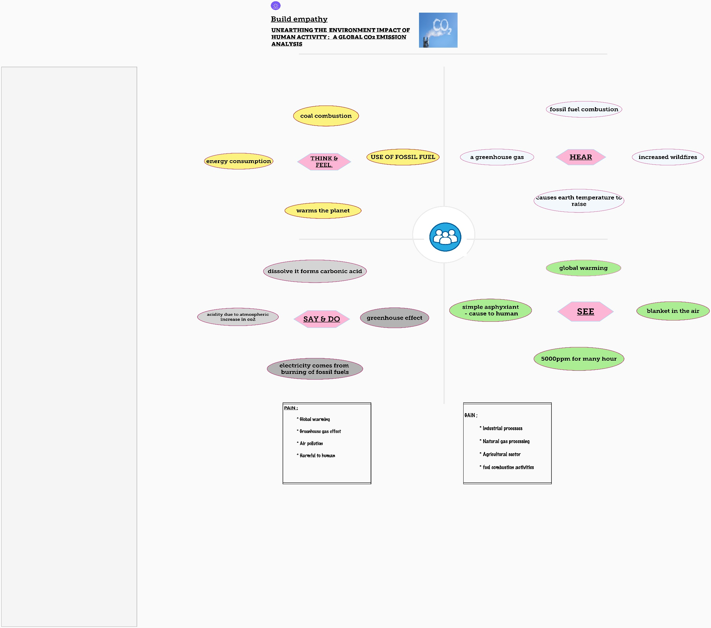**2.1 EMPATHY MAP :**

**2.2 BRAINSTROMING :**

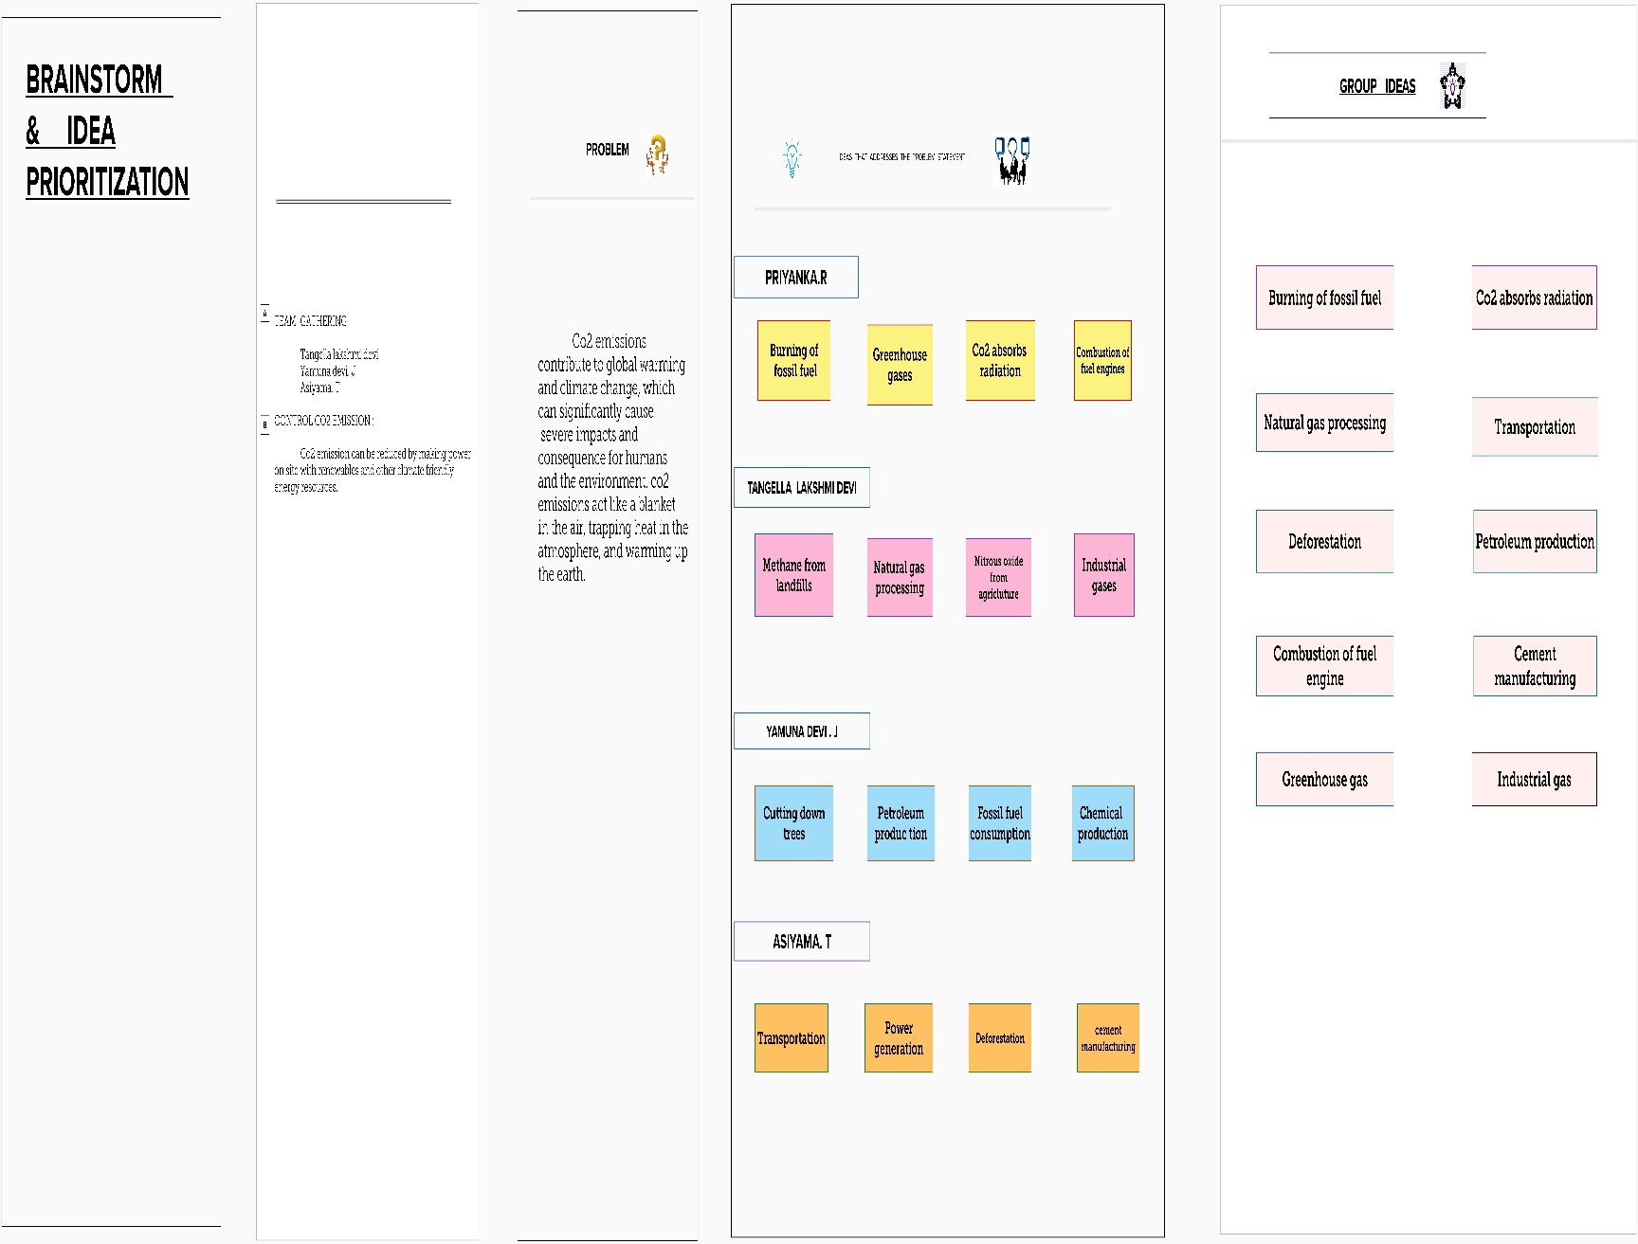

**3.RESULT**

DASHBOARD 1:

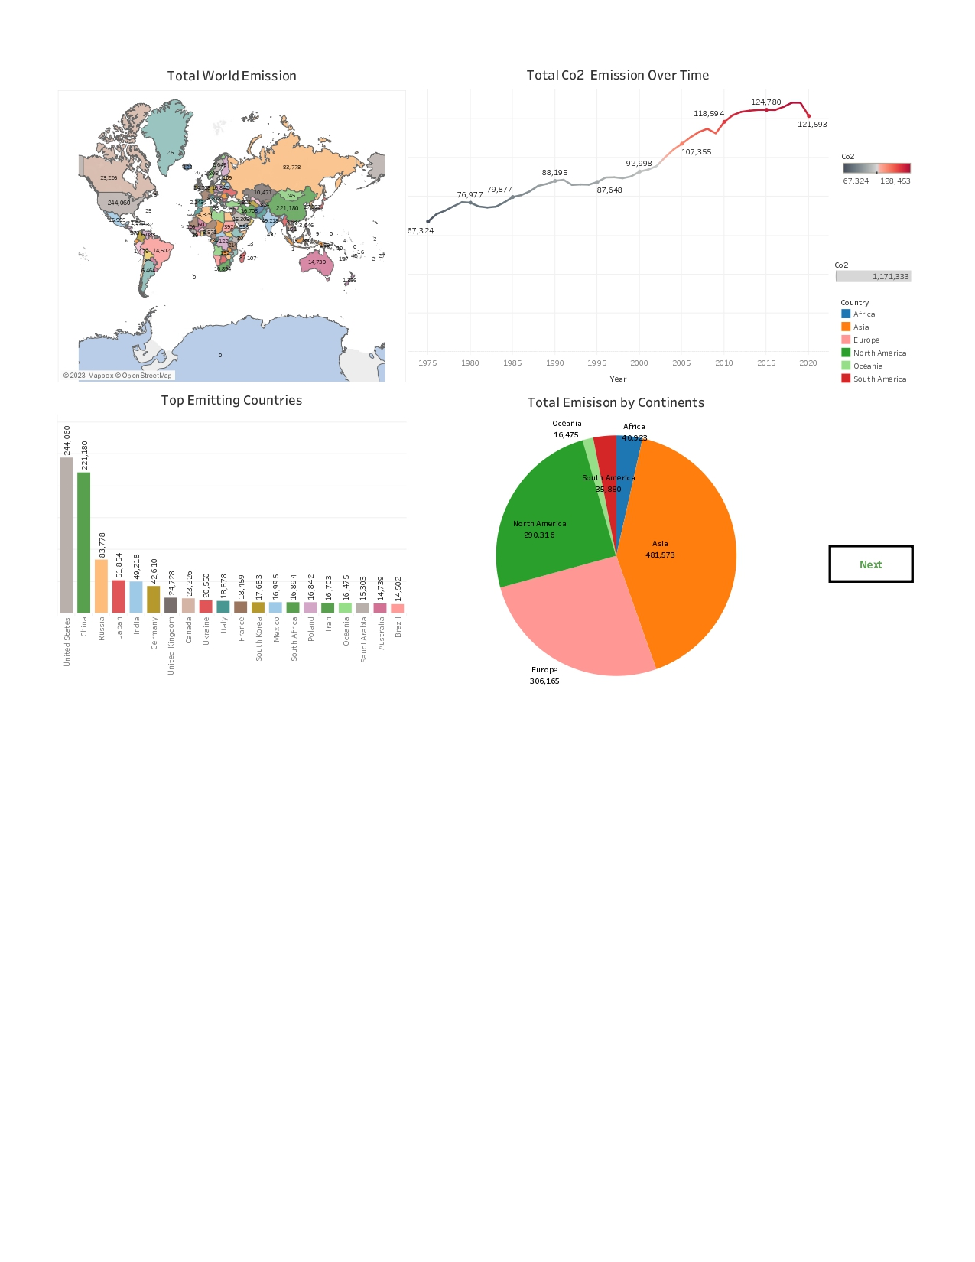

**DASHBOARD 2:**



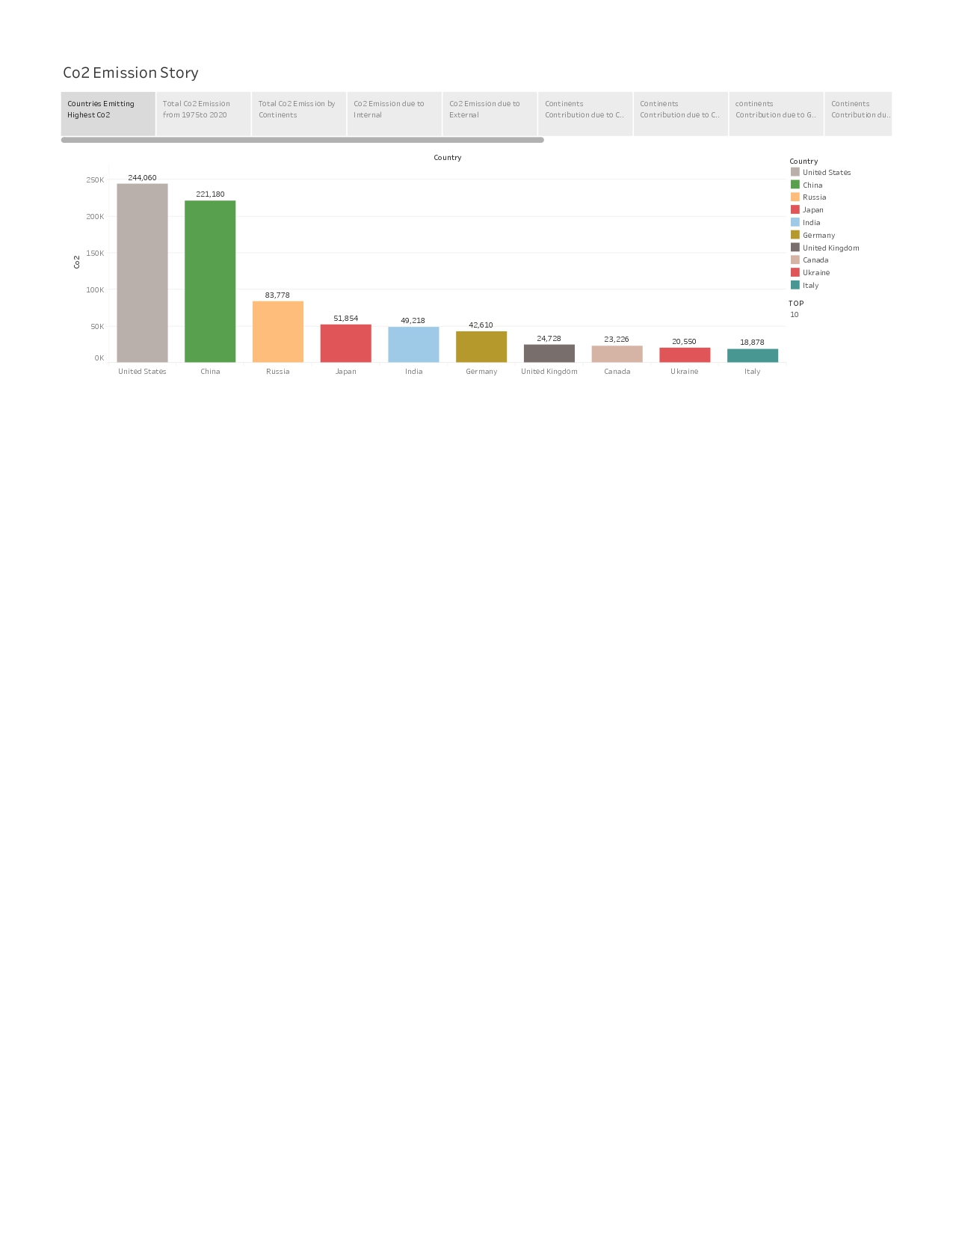DASHBOARD 3:

STORY:

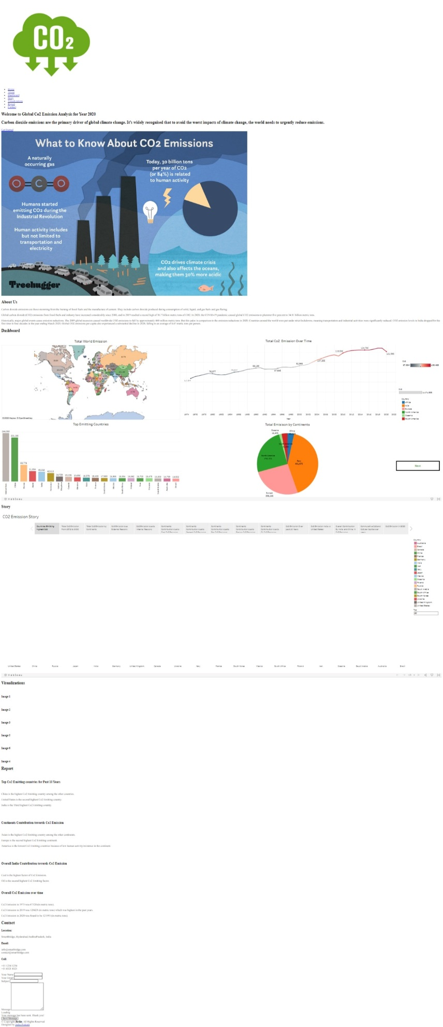 **INTEGRATION :**

**4. ADVANTAGES & DISADVANTAGES**

Advantages :

**Carbon dioxide is an important greenhouse gas that helps to trap heat in our atmosphere. Without it, our planet would be inhospitably cold. However, an increase in co2 concentrations in our atmosphere is causing average global temperatures to rise, disrupting other aspects of earth’s climate.**

**Disadvantages :**

Carbon dioxide in the atmosphere warms the planet causing climate change. Human activities have raised the atmosphere’s carbon dioxide content by 50% less than 200 years.

**5. APPLICATIONS**

In 2025, Natural gas is projected to account for 27% of electricity generation and 18% of electricity related co2 emission.

**6. CONCLUSION**

**Co2** Emission contributes to global warming and climate change, which can significantly cause severe impacts and consequence for humans and the environment. Co2 Emission can be reduced by making power on site with renewables and other climate friendly energy resources.

**7. FUTURE SCOPE**

Co2 can also replace fossil fuels as a raw matetrials in chemicals and polymers. Less energy intensive pathways include reacting co2 with minerals or waste streams. Such as iron slag, to form carbonate for building materials.

**8. APPENDIX**

**A. SOURCE CODE**

file:///C:/Users/user/Downloads/index%20(1).htmlobal Co2 Emission Analysis